Instructions:
The purpose of this lab is to introduce professional git version control and repo management while learning fundamentals of SDR programming in GNURadio with the HackRF SDR. Plan ahead since this is a very time-consuming lab but required to progress to more advanced topics.
- Setup a GitHub repository for EEGR4613 to store all your SDR labs. Be sure to provide a link to share the repository with the instructor. See my example repo, which you are allowed to fork for class-use.
Setup
Open a GitHub account with your personal email address, then optionally sign up for GitHub Education with your LETU email for free access to premium features. A detailed tutorial is provided at https://docs.github.com/en/get-started/onboarding/getting-started-with-your-github-account. If you’re new to Git and GitHub, I strongly suggest working through “start your journey”, “OnBoarding”, “Git Basics”, and “Using Git”. I also suggest setting up SSH key authentication on your personal computer for ease of use. This may not be as practical for the lab machines.
Motivation for Git
The motivation for using version control is to firstly to prevent loss of work. By creating snapshots of work frequently and backing it up in a compact format, collaborators can rest easy knowing their work is recoverable if local changes cause corruption or data loss. This is further augmented by pushing up to a cloud provider like GitHub. Secondly, version control provides a clear chain of custody and work history. This is often called the “blame” in industry since it makes it very clear who is to blame when problems arise . Thirdly, version control creates a framework for collaboration and enables review and merge procedures, often called pull requests.
Brief Overview of Git
Git is a version control system that tracks who, how, and why files in a project were changed. These changes are tracked by taking the difference (diff) between files and storing an archive of those changes to build each intermediate step called commits. Git runs on your local machine, whereas GitHub is the “remote” cloud storage server used to host repositories.
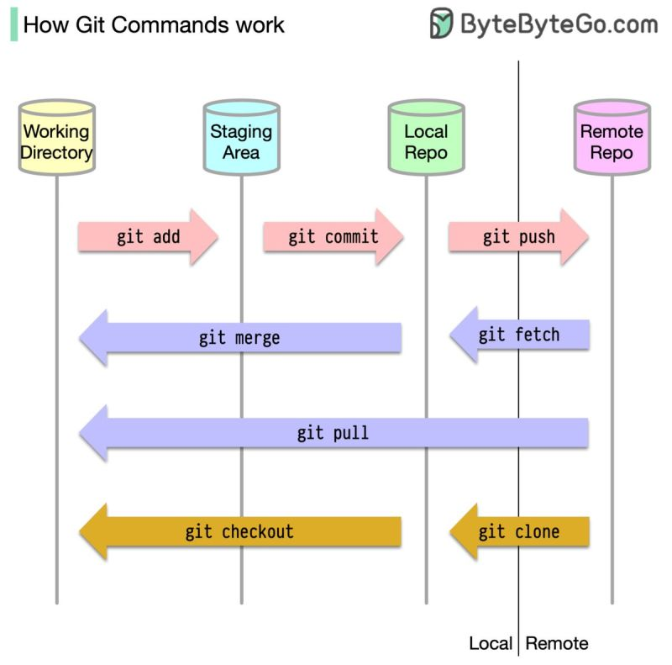
Figure 1: Common Git workflow commands with dataflow showing that data is cloned, then push/pull to/from the remote repository

General Git workflow
For a new repository, go to GitHub and create a new repository, then clone it to the working directory of your choosing with the ‘git clone’ command. When you make sufficient changes such they it would a critical loss to lose the work, you should create a snapshot of your work by creating a commit. To create a commit, start using the `git status` command to check for changed files. Then use the `git add` command to add each file you wish to save to the local staging area. Once all desired files are added, use the `git commit –“message here”` command to save the snapshot to your local Git repository with a descriptive message denoting the changes that were made. Note, at this point the changes are saved in a commit only on your local machine. You can confidently move to another commit by using the `git checkout` command without risking loss of work; however, the remote repository on GitHub has not received the changes yet. To update the repository on GitHub, use the `git push` command. It is strongly recommend to push at least daily when actively working and make a commit as often as you’re willing to redo work. Figure 1 shows the use of these common commands.
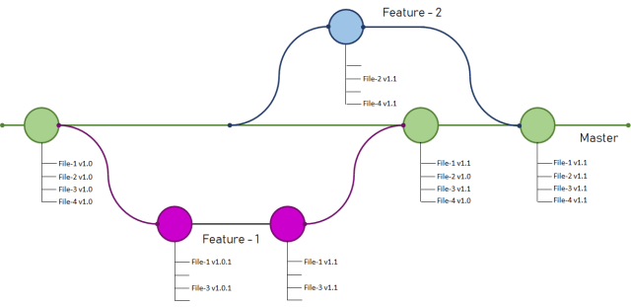
Figure 2: Feature Branch Git workflow showing two features branches that get sequentially merged with the master branch.
A simple multi-person Git workflow is the feature branch workflow. In this workflow each person or each new feature is developed in its own feature branch. When a branch is ready to merge, then a pull request is created. A pull request is a formal process where a maintainer of the receiving branch must review and approve of the incoming code in the feature branch before merging.
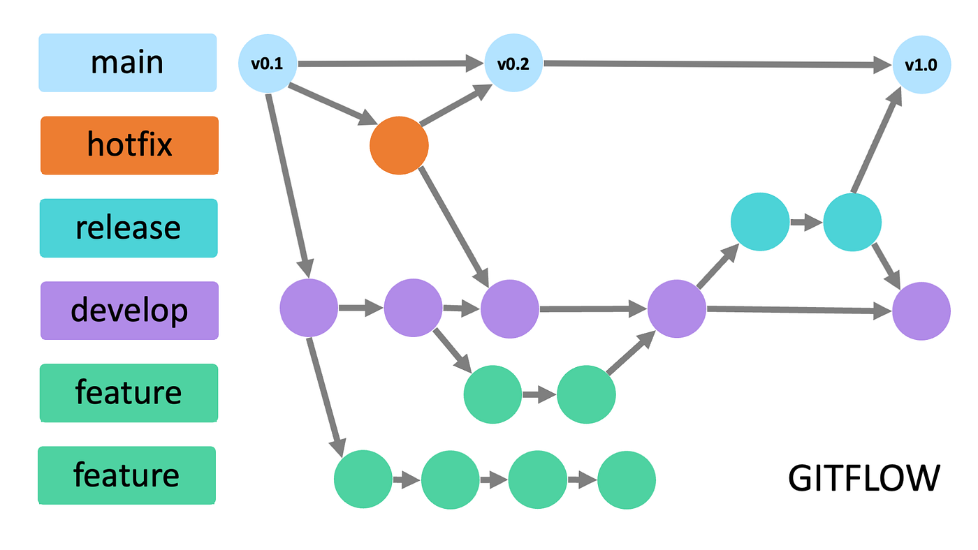
Figure 2: Gitflow git workflow showing one public-facing main branch with release version tags.
The workflow that I follow in my software projects is a slightly extended version called the Gitflow workflow. There is one public-facing main branch that consists of functional releases that are tagged with their respective software version, often with downloadable links for the compiled code. In general, all developers are allowed to branch from or push to the develop branch after passing the required continuous integration and pull request procedures. Developers work freely in each feature branch until they are functional and ready to integrate to the develop branch. When a public-facing set of features are ready for release, the release branches contains commits required to ensure smooth release to the public. When a release is ready, only a maintainer (usually a senior dev responsible for the project) can merge the release branch to the main branch and tag it. In the real-world, things do go wrong, so hotfix branches are used for critical updates that do not have time to progress through the entire Gitflow process.
Merge conflicts are beyond the scope of this brief tutorial and will be addressed individually by the instructor or as part of a lecture if conditions deteriorate.
Notes of Caution
Ordinarily, developers only use Git for text-readable files and code since binary files cannot be parsed by Git. When a binary file is committed to a repo, everytime a change is made to it, the entire file gets committed instead of simply the changes. This drastically increases the size of the repo and is strongly frowned upon in software repos. HOWEVER, in the software-defined radio and PCB design industry, we exempt this rule by creating repositories dedicated to hardware infused purposes with the expectation that the repos will be larger and don’t always follow good Git practices as a compromise for practicality. In our class, our binaries are very small, so they are included for quick evaluation by the instructor. Generally, only the Python file is required for GNU radio.
- Work through each tutorial in these sections at https://wiki.gnuradio.org/index.php/Tutorials
  - Introducing GNU Radio
  - Flowgraph Fundamentals
  - Creating and Modifying Python Blocks
  - DSP Blocks
  - Core GNU Radio Mechanics
Place all completed flowgraphs with the required files for demonstration in separate folders in your EEGR4613 GitHub repository. Don’t forget to push!
- Exemplary: Follow the narrowband FM tutorial and demonstrate reception of a local NBFM radio station from the HackRF. Instructions for the osmocom source block can be found in this video. Provide proof of operation with a short video or other method linked inside your report.

Deliverables:
- Provide an accessible link to your EEGR4613 GitHub repo at the beginning of your report.
- Complete each tutorial listed in step 2 and upload the functional flowgraph to your repo, with a dedicated folder for each flowgraph.
- Provide a clear and easy to understand README file in the markdown language for each flowgraph in the tutorials.
The file structure should be as follows:
- Lab02
  - First flow graph name
    - .grc
    - .py (if compiled)
    - Other assets
    - README.md
- Professional, typed report that shows results with explanations. Only include results graphs, not screenshots of the flowgraph since that is provided by the tutorials.
- Cite ALL sources in IEEE format as in-line (footnotes) or in a bibliography.
- The format shall be a single or double-column document that contains labeled figures, tables, and diagrams with a cover page and abstract describing the varying levels of success in the lab.
